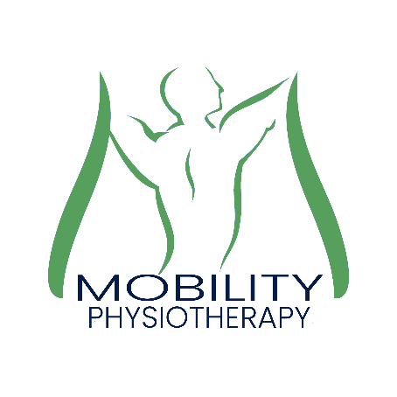
Mobility Physiotherapy Limited
Unit 1, 81 Main street
Bishopthorpe
YORK
YO23 2RA
TEL : 07954 327405
emma@mobilityphysiotherapy.co.uk
www.mobilityphysiotherapy.co.uk

Acupuncture and Dry-Needling Consent form

Acupuncture and Dry-Needling are treatment techniques in which fine, sterile needles are inserted into specific parts of the body to produce a therapeutic effect -such as pain relief or improved muscle function.

Acupuncture and Dry-Needling are generally very safe. Serious side effects (including pierced internal organ or nerve injury) are very rare occurring in less than 1 per 10,000.

You’ll need to be aware that:
- Drowsiness occurs after treatment in a small number of patients and if affected, you are advised not to drive.
- Minor bleeding or bruising can occur post treatment in a small number of cases
- Pain during treatment can occur in a small number of cases.
- Existing symptoms can get worse after treatment in a small number of cases
- Fainting can occasionally occur in certain patients, particularly at the first treatment
- Single-use, disposable needles are always used in clinic.
- All Physiotherapists at the clinic providing this treatment have undertaken recognised external training to become proficient in delivering this form of treatment.

In addition, if there are particular risks that apply in your case, your practitioner will discuss them with you.

Is there anything your Physiotherapist needs to know? Tick as applicable
- If you are pregnant, or are trying to become pregnant? YES NO
- If you have ever experienced a seizure, faint or funny turn? YES NO
- If you have a pacemaker or any other electrical implants? YES NO
- If you have a metal allergy or needle phobia? YES NO
- If you are diabetic, immune-deficient or a history if cancer: YES NO
- If you are taking anti-Coagulants (blood thinning) or any other
Medications: YES NO
- If you have a damaged heart values or unstable heart condition: YES NO
- If you have any blood disorders (Haemophilia, HIV, AIDS, Hepatitis C) YES NO

Statement of consent
I have read the above consent form. I have also had the opportunity to ask questions about its content, and by signing below, I agree to the above mentioned Acupuncture or Dry-Needling procedures. I intend this consent form to cover the entire course of treatments for my present and future conditions for which I seek treatment. I am aware that I can refuse treatment at any time.

PRINT NAME: | SIGNATURE: | DATE:
PRINT NAME: | SIGNATURE: | DATE:

